Date: 11.8.2017

PEP8 Tool:

I referred this link,

https://www.python.org/Dev/peps/pep-0008/
https://pypi.python.org/pypi/pep8
https://pypi.python.org/pypi/autopep8

Installation Steps:

Step1: Installed sudo pip install pep8
Step2: sudo pip install --upgrade pep8
Step3: pep8 tool used to Online Quiz application

I have use PEP8 tool in Online Quiz application and I tried to run this application.

Run commend:
<application - folder path> pep8 –first <file name>

For Example:

admin.py in Online Quiz

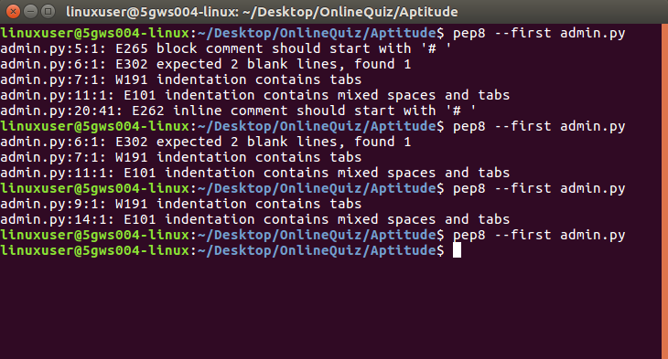

Displayed some errors in online quiz application such as,

admin.py

admin.py:5:1: E265 block comment should start with '# '
admin.py:6:1: E302 expected 2 blank lines, found 1
admin.py:7:1: W191 indentation contains tabs
admin.py:11:1: E101 indentation contains mixed spaces and tabs
admin.py:20:41: E262 inline comment should start with '# '

models.py

models.py:9:1: E303 too many blank lines (3)
models.py:10:1: W191 indentation contains tabs
models.py:23:1: E302 expected 2 blank lines, found 1
models.py:24:1: E101 indentation contains mixed spaces and tabs
models.py:26:16: E225 missing whitespace around operator
models.py:53:1: W391 blank line at end of file

urls.py

urls.py:6:1: W191 indentation contains tabs
urls.py:6:1: W293 blank line contains whitespace
urls.py:8:80: E501 line too long (81 > 79 characters)
urls.py:21:1: E101 indentation contains mixed spaces and tabs
urls.py:21:5: E116 unexpected indentation (comment)
urls.py:21:5: E303 too many blank lines (2)
urls.py:29:1: W391 blank line at end of file

views.py

views.py:16:1: E302 expected 2 blank lines, found 1
views.py:17:26: E231 missing whitespace after ','
views.py:22:13: E251 unexpected spaces around keyword / parameter equals
views.py:50:40: E225 missing whitespace around operator
views.py:52:44: W291 trailing whitespace
views.py:58:10: E114 indentation is not a multiple of four (comment)
views.py:58:10: E116 unexpected indentation (comment)
views.py:67:1: W293 blank line contains whitespace
views.py:94:1: W391 blank line at end of file

setting.py

settings.py:13:10: E401 multiple imports on one line
settings.py:57:1: E303 too many blank lines (3)
settings.py:92:80: E501 line too long (91 > 79 characters)

urls.py

urls.py:20:1: E101 indentation contains mixed spaces and tabs
urls.py:20:1: W191 indentation contains tabs
urls.py:21:5: E131 continuation line unaligned for hanging indent

Finally, This error settings.py:92:80: E501 line too long (91 > 79 characters) not clear.
So, I have used “ \ ” in settings.py

setting.py

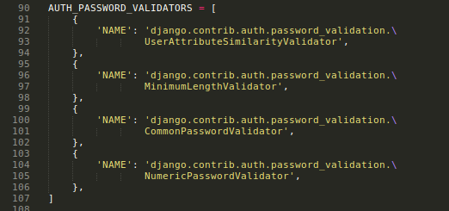

Finally, I cleared all errors one by one in Online Quiz application

Result:

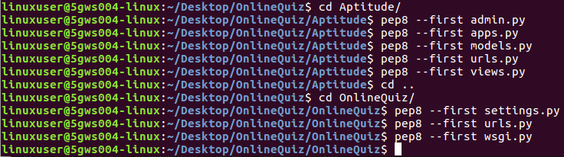

Auto PEP8 Tool:

Next, I learned ‘what is auto pep8?’ and ‘how to work?’.
I referred this link ,

https://pypi.python.org/pypi/autopep8

Installation Steps:

Step1: sudo pip install --upgrade autopep8
Step2: autopep8 --in-place --aggressive --aggressive <filename>

First I installed sudo pip install –upgrade autopep8, Next I tried to workout in my application.

For example:
autopep8 --in-place --aggressive –aggressive /home/linuxuser/Desktop/OnlineQuiz/OnlineQuiz/settings.py

(or)

(env)linuxuser@5gws004linux:~/Desktop/OnlineQuiz/OnlineQuiz$ autopep8 --in-place --aggressive –aggressive urls.py

